

**CAPSTONE PROJECT REPORT**

**Report 1 – Project Introduction**

– Hanoi, October 2023 –

**Table of Contents**

I. Record of Changes 3

II. Project Introduction 4

1. Overview 4

1.1 Project Information 4

1.2 Project Team 4

2. Product Background 4

3. Existing Solutions 5

4. Business Opportunity 5

5. Software Product Vision 6

6. Project Scope & Limitations 6

6.1 Major Features 6

6.2 Limitations & Exclusions 7

# I. Record of Changes

| **Date** | **A* M, D** | **In charge** | **Change Description** |
| --- | --- | --- | --- |
| 16/09/2023 | A |  | Create Project Introduction |
|  |  |  |  |
|  |  |  |  |
|  |  |  |  |
|  |  |  |  |
|  |  |  |  |
|  |  |  |  |
|  |  |  |  |
|  |  |  |  |
|  |  |  |  |
|  |  |  |  |
|  |  |  |  |
|  |  |  |  |

*A - Added M - Modified D - Deleted

# II. Project Introduction

## 1. Overview

### 1.1 Project Information

* Project name: **HealthCheck System**
* Vietnamese name: **Hệ thống quản lý về khám sức khỏe**
* Project code: ***HCS***
* Group name: **SEP490_G74**
* Software type: ***Web application***

### 1.2 Project Team

| **Full Name** | **Role** | **Email** | **Mobile** |
| --- | --- | --- | --- |
| Pham Duc Thang | Lecturer | ThangPD10@fe.edu.vn | 0912345678 |
| Truong Quang Son | Leader | sontqh153230@fpt.edu.vn | 0865212417 |
| Nguyen Khac Son | Member | sonnkhe151341@fpt.edu.vn | 0384104668 |
| Bui Trung Kien | Member | kienbthe150611@fpt.edu.vn | 0982797866 |
| Bui Trung Thinh | Member | thinhbthe151530@fpt.edu.vn | 0352741927 |

## 2. Product Background

The development of medical practice management software for clinics is a natural response to the current state of the healthcare industry and the continuous advancement of information technology. Clinics worldwide face a range of challenges in managing patient information, the medical examination process, results, and healthcare service payments. Traditional paper-based management systems have become less efficient, prone to data loss, time-consuming, and have resulted in the inefficiency of healthcare service delivery.

Simultaneously, patient demands for convenience, consistency, and security in the healthcare process are on the rise. Physicians, nurses, cashiers, and clinic managers all require an efficient means to manage patient information, appointment scheduling, medical record-keeping, and financial management.

The aim of developing this product is to address these challenges by providing a comprehensive, integrated, and efficient software platform for all roles within a clinic. Physicians can access patient information swiftly, record medical examination results, and plan treatment. Nurses have tools to assist physicians, manage patient records. Cashiers can easily create invoices, collect service fees, and track financial records. Clinic manager has the ability to supervise all financial activities as well as manage the members in the clinic

The product's goal is not only to enhance clinic workflow but also to improve the patient experience. By streamlining processes, reducing waiting times, and ensuring patient data is protected and secure, this product promises to play a vital role in improving the quality of healthcare services and meeting the growing demands of the industry.

## 3. Existing Solutions

In the healthcare industry, there are numerous existing solutions that can provide valuable information and essential features for the design of our system, even though our system does not directly interact with patients. Here are some common solutions:

* Electronic Health Record (EHR) Systems: EHR systems, such as EPIC or Cerner, offer valuable insights into managing patient records and medical information. They provide solutions for patient data management, medical history, and examination results, even though they do not directly interact with patients.
* Medical Practice Management Software: Medical practice management software, like Medisoft or Practice Fusion, provides features for appointment scheduling, patient billing, and patient record management. They can serve as a basis for considering how to plan appointments and manage finances in our system.
* Hospital Information Systems (HIS): HIS platforms are comprehensive information management systems used in larger healthcare facilities. They offer a foundation for patient information management, billing, and medical records, although they are not directly related to patients.
* Pharmacy Management Systems: For clinics with in-house pharmacies, pharmacy management systems provide inventory control, medication dispensing, and medication management. They can offer insights into managing pharmacy services in our system.

By examining these existing solutions and their features, we can learn from best practices, industry standards, and potential risks to design a comprehensive and effective clinic management software that meets the specific needs of physicians, nurses, cashiers, and clinic managers in our development, even though our system does not directly interact with patients.

## 4. Business Opportunity

* Business Opportunity: The business opportunity for our clinic management software lies in addressing the pressing needs of small healthcare clinics in the field of outpatient clinic management. Our product is designed to operate in the highly competitive market of healthcare information systems, especially in the domain of outpatient clinic management. It helps bridge a critical gap in the market and offers unique advantages.
* Market Overview: The healthcare sector is experiencing rapid growth, with an increasing demand for streamlined operations, improved patient care, and enhanced financial management. In this context, outpatient clinics, especially small clinics, are looking for modern and integrated solutions to manage their operations more effectively.
* Current Market State: Existing solutions in the market, such as Electronic Health Records (EHR) systems and medical practice management software, primarily focus on patient records and billing. However, they often lack the comprehensive tools needed to efficiently manage the operations of small outpatient clinics.
* Unmet Needs: Our clinic management software aims to fill this gap by providing a specialized platform customized for the specific needs of small outpatient clinics. It combines patient record management, billing, financial management, and pharmacy services in an integrated package. This addresses the unique challenges that small clinics face, offering a holistic solution that current products often do not provide.
* Market Trends: The healthcare industry is moving toward increased digitalization and the adoption of technology-driven solutions. Telemedicine, remote consultations, and integrated financial management are becoming common practices. Our product aligns with these trends, offering features that enhance operational efficiency and provide a foundation for future scalability.

## 5. Software Product Vision

Our software product envisions a healthcare landscape where outpatient clinic management is simplified, patient care is optimized, and financial operations are streamlined. It is a vision of a world where outpatient clinics, regardless of their size, can efficiently manage their operations, freeing up healthcare professionals to focus on what they do best - caring for patients.

In this world, clinic staff can seamlessly access patient records, process billing, and manage pharmacy services within a unified, user-friendly platform. Patients experience the convenience of efficient healthcare services, reduced waiting times, and personalized care.

Our product's vision aligns with the evolving healthcare trends of digitalization, telemedicine, and integrated financial management. It empowers clinics to adapt to these trends, enhancing their ability to provide quality care. It also resonates with our organization's strategic commitment to delivering innovative and practical solutions within the healthcare technology sector.

This vision is not just idealistic but grounded in the real needs of diverse customers, the evolving healthcare landscape, and the resource constraints of our development organization. Our software product strives to bridge the gap between the demands of modern healthcare and the capabilities of outpatient clinics, offering a solution that transforms the way clinics operate and enhances the patient experience.

## 6. Project Scope & Limitations

### 6.1 Major Features

* FE-01: User and access management
* FE-02: Service management
* FE-03: Medicine management
* FE-04: Medical record management
* FE-05: Invoice management
* FE-06: Ptient management
* 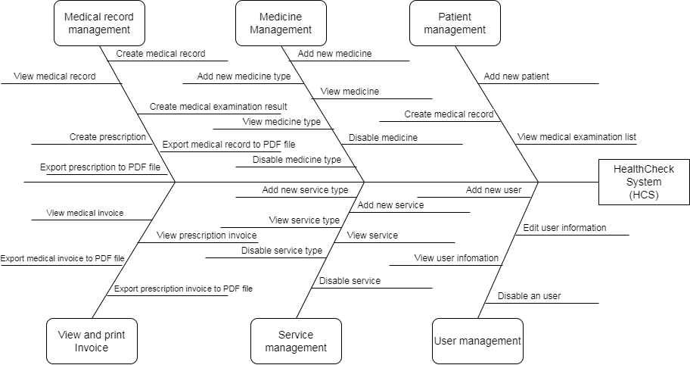

### 6.2 Limitations & Exclusions

LI-1: The application cannot yet integrate information from the Ministry of Health.

LI-2: Direct consultation will not be as accurate as direct examination in some cases.

LI-3: Only works on the web